**ELECTRICAL**

Light Fixture repair/Replace 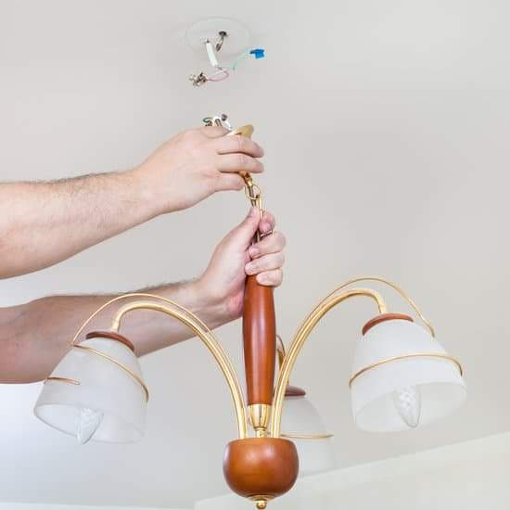

Ceiling Fan Repair/Replace 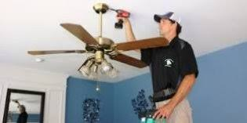

Switch and Outlet Repair 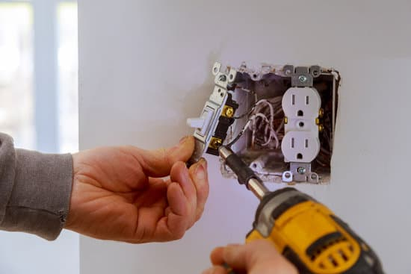

CO2/Smoke Detectors 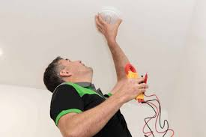

Lamp Repair 